Introduction to Amazon Aurora

Lab Steps

Task 1: Sign in to AWS Management Console
- Click on the Open Console button, and you will get redirected to AWS Console in a new browser tab.
- On the AWS sign-in page,
  - Leave the Account ID as default. Never edit/remove the 12 digit Account ID present in the AWS Console. otherwise, you cannot proceed with the lab.
  - Now copy your User Name and Password in the Lab Console to the IAM Username and Password in AWS Console and click on the Sign in button.
- Once Signed In to the AWS Management Console, Make the default AWS Region as US East (N. Virginia) us-east-1.

Task 2: Create a Security Group for RDS instance
In this task, we'll create a security group for RDS in the N.Virginia region with port 3306 enabled.
- Make sure you are in the N.Virginia Region.
- Navigate to EC2 by clicking on the Services menu available under the Compute section.
- On the left panel menu, Select the security group under the Network & Security section.
- Click on the Create security group button.
- We are going to create a Security group for RDS with a 3306 port number enabled.
  - Security group name : Enter Aurora_lab_sg
  - Description: Enter Security group for RDS Aurora
  - VPC: Select Default VPC
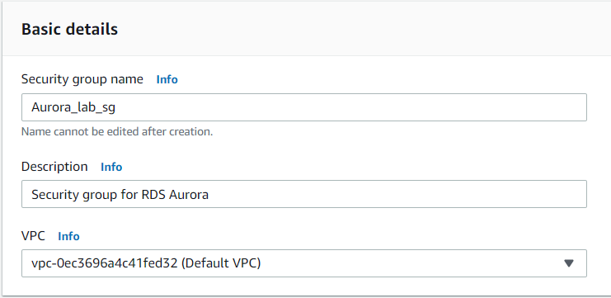
- Click on the Add rule button under Inbound rules.
  - Type: Select MYSQL/Aurora
  - Source: Select Custom
  - In the textbox add 0.0.0.0/0
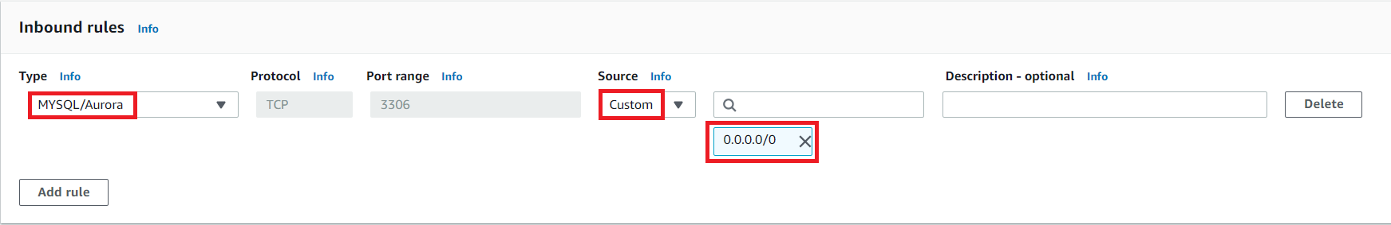
- Leave everything as default and click on the Create security group button.

Task 3: Create an RDS Database Instance
- Make sure you are in the N.Virginia Region.
- Navigate to RDS by clicking on the Services menu available under the Databases section.
- Click on Databases (in the left panel) and click on Create database button.
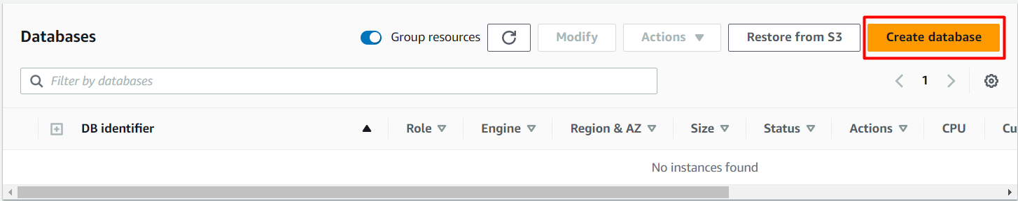
4. Choose a Database Creation Method:
- Select Standard Create
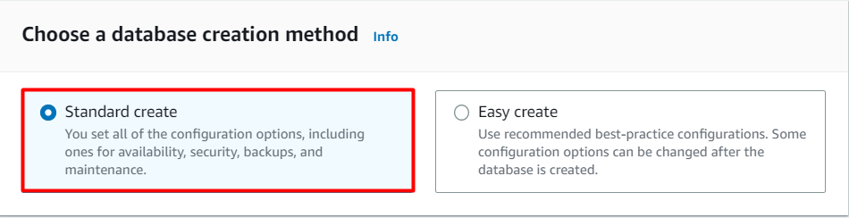
5. In Engine options:
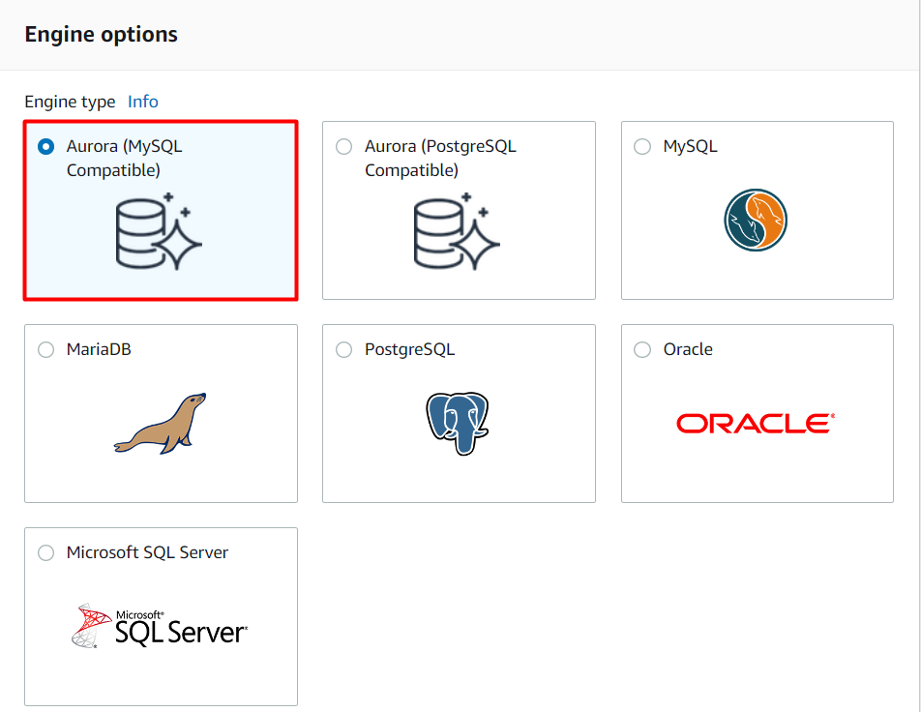
- Engine type: Choose Aurora (MySQL Compatible)
- Available Versions: Select Aurora (MYSQL 5.7) 2.11.2) - Choose this version only
6. Templates
- Select Dev/Test
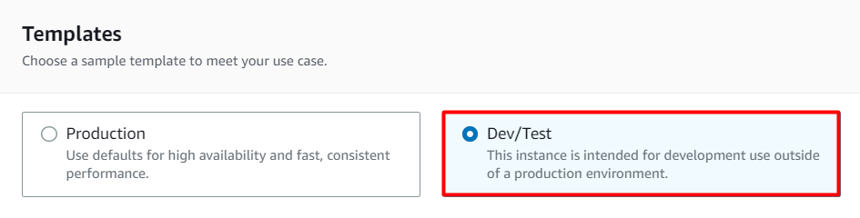
- Settings (Aurora Cluster Settings)
  - DB cluster identifier: Specify cluster name MyAuroraCluster
  - Credentials Settings (specify the details)
    - Master Username: Enter WhizlabsAdmin
    - Master password: Enter Whizlabs123
    - Confirm password: Enter Whizlabs123
    - Note: This is the username and password used to log onto your database. Please make note of them.
- DB instance size
  - DB instance class: Select Burstable classes (includes "t" classes)
  - Choose db.t3.small from the list.
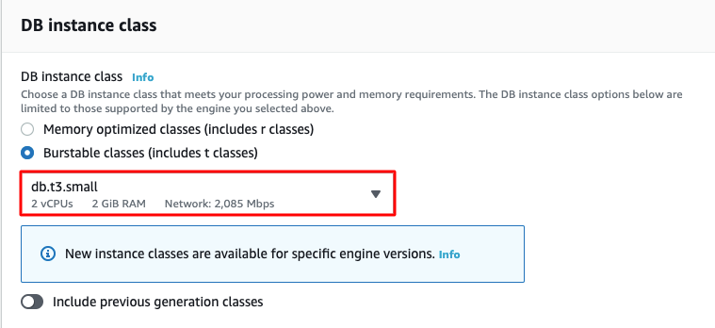
9. Availability & durability
- Multi-AZ deployment: Choose Don't create an Aurora Replica
10. Connectivity
- Virtual Private Cloud (VPC): default
- Additional connectivity configuration
  - Subnet group: Leave it as default
  - Publicly access: Select Yes
  - Existing VPC security groups :
    - Remove the Default security group, which is selected by default. Select Aurora_lab_sg for the dropdown.(This is the security group which you have created in the beginning)

- Availability zone: No Preference
- Database port: 3306
11. Monitoring: Uncheck the Enable enhanced monitoring checkbox
- Additional configuration
  - Database options
    - Initial database name: Enter MyDB
    - DB cluster parameter group: default (default.aurora-mysql5.7)
    - DB parameter group: default (default.aurora-mysql5.7)
    - Failover priority: default (No preference)
  - Backup
    - Backup retention period: default (1 day)
    - Copy tags to snapshots: default (checked)
  - Encryption: Uncheck the Enable encryption checkbox
  - Backtrack : Leave it as default
  - Log exports: Leave it as default
  - Maintenance
    - Enable auto minor version upgrade: default
    - Maintenance window: default (No Preference)
  - Deletion protection
    - Enable deletion protection: Uncheck the checkbox
- Once all the configurations are done properly, click on the Create database button.
- On the RDS console, the details for the new DB instance appear. The DB instance will show the status "creating" until the DB instance is ready to use. When the state changes to Available, you can connect to the DB instance. It can take up to 5-10 minutes before the new instance status becomes Available.
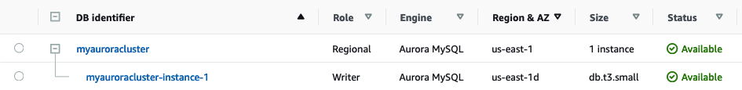

Task 4: Connecting to an Amazon Aurora MySQL RDS Database on a DB Instance.
In this example, we will connect to a database on an Amazon Aurora MySQL DB instance using MySQL commands. To connect to a database on Amazon Aurora, find the endpoint (DNS name).
- Navigate to Databases and click on myauroracluster.
- Under Connectivity & security section:
  - The endpoints Writer and Reader are provided.
  - Copy and note the endpoint of the Writer.
  - Endpoint: myauroracluster.cluster-cdegnvsebaim.us-east-1.rds.amazonaws.com
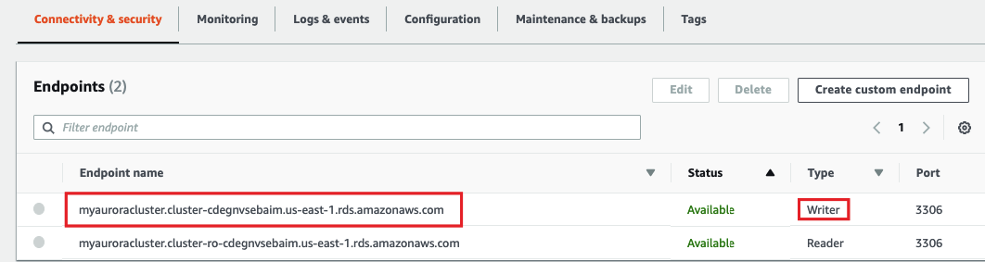
- Depending on if you have Linux, iOS, or Windows on your machine, follow the steps below.
Note: For Linux/Mac users, please scroll to the Task 7.

Task 5: Connecting from a Windows Machine
- Download MySQL Workbench and install.
- Once installed, open MySQL Workbench.
- Click on Plus icon besides MySQL Connections.
  - Enter the Following Details:
    - Connection Name : Enter Amazon Aurora
    - Connection Method : Select Standard (TCP/IP)
    - Hostname : Enter myauroracluster.cluster-cdegnvsebaim.us-east-1.rds.amazonaws.com
    - Port : 3306
    - Username : Enter WhizlabsAdmin
    - Password : Click on Store in Vault and enter a password.
      - Password: Enter Whizlabs123
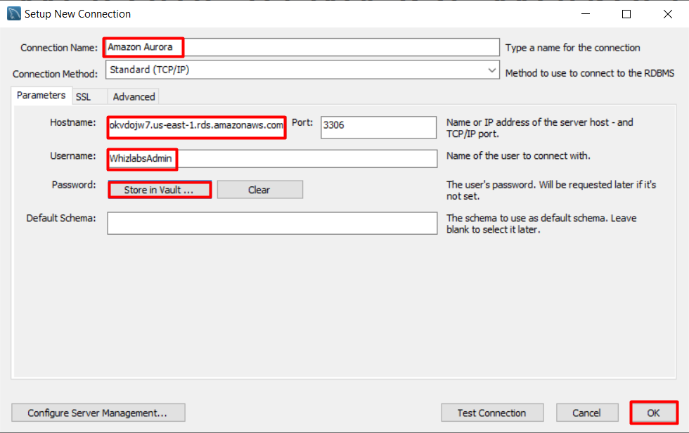
- Click on OK button.

Task 6: Execute Database Operations for Windows users
- Once the connection is tested, it will be shown like this, double click on it.
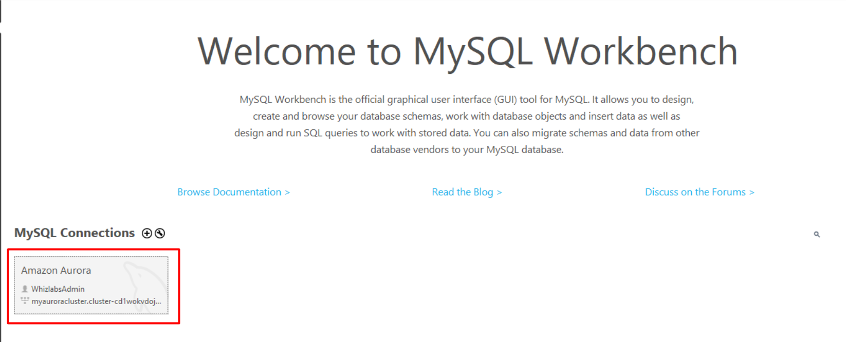
2. It will take around 1 minute to verify your connection and then launch the MySQL workbench editor.
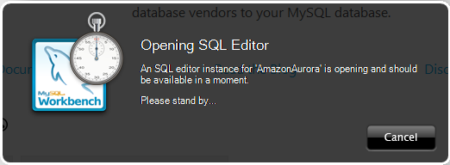
3. MySQL workbench editor looks like this, click on the first SQL tab, highlighted in the SQL editor.
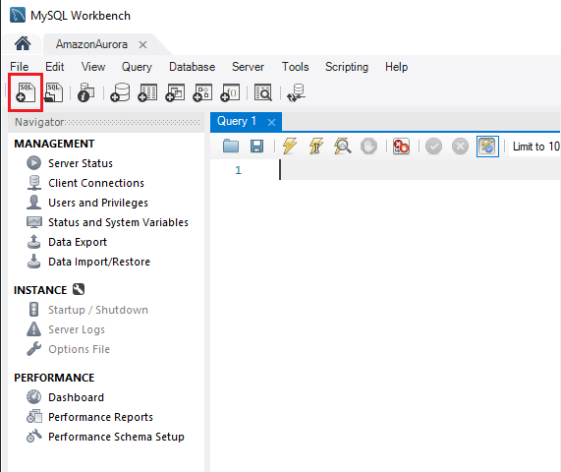
4. To show the list of databases present, paste the below statement in the query editor, and click on Execution icon:
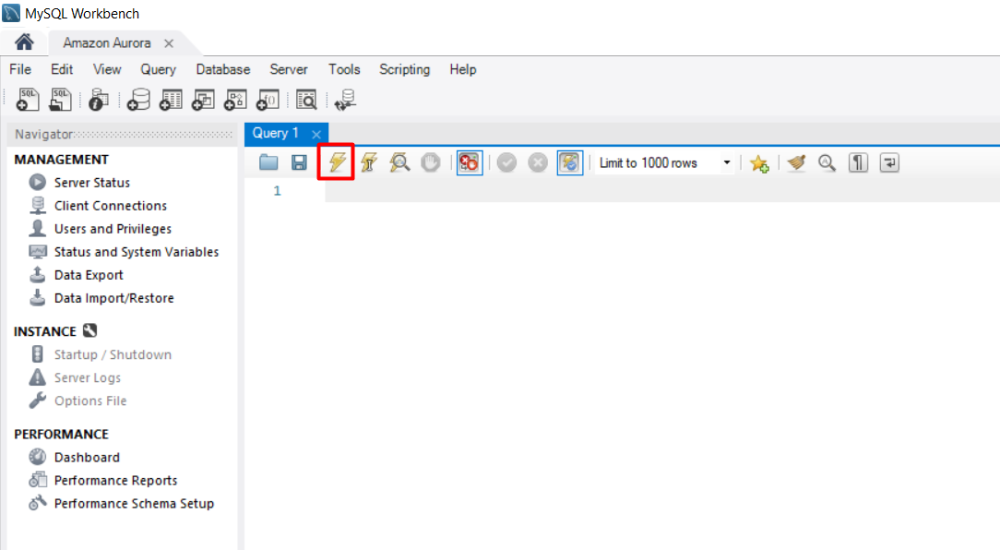
5. Note: After executing every command, clear the previous command.
show databases;
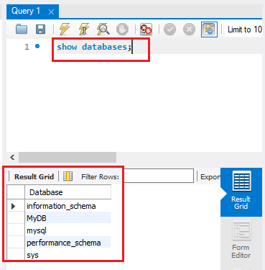
6. To delete the MyDB, paste the below statement in the query editor, and click on the Execution icon:
drop database MyDB;
7. To create a database, paste the below statement in the query editor, and click on Execution icon.
create database SchoolDB;
8. View the database created, paste the below statement in the query editor, and click on Execution icon.
show databases;
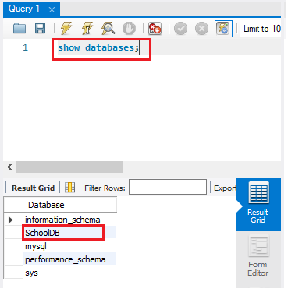
9. Switch the database SchoolDB, paste the below statement in the query editor, and click on Execution icon.
use SchoolDB;
10. Create a sample table of students.
CREATE TABLE students (
subject_id INT AUTO_INCREMENT,
subject_name VARCHAR(255) NOT NULL,
teacher VARCHAR(255),
start_date DATE,
lesson TEXT,
PRIMARY KEY (subject_id));
11. To view the students table, paste the below statement in the query editor, and click on Execution icon.
show tables;
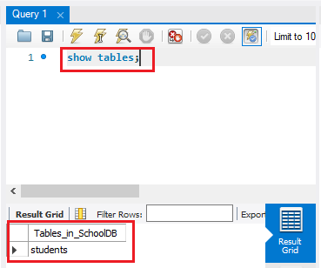
12. Insert data into the table:
INSERT INTO students(subject_name, teacher) VALUES ('English', 'John Taylor');
INSERT INTO students(subject_name, teacher) VALUES ('Science', 'Mary Smith');
INSERT INTO students(subject_name, teacher) VALUES ('Maths', 'Ted Miller');
INSERT INTO students(subject_name, teacher) VALUES ('Arts', 'Suzan Carpenter');
13. Check the items added in the table
select * from students;
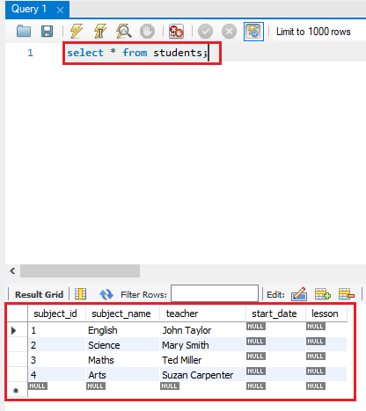

Task 7: Connecting from a local Linux/iOS Machine
- Open Terminal and enter the following command:
- Syntax : mysql -u <master username> -p -h <Aurora-DNS-Name-Writer>
- mysql -u WhizlabsAdmin -p -h myauroracluster.cluster-cdegnvsebaim.us-east-1.rds.amazonaws.com
- Click Enter.
- Enter the Master password while configuring Aurora.
  - Whizlabs123. Click Enter.
- You will be successfully logged into Amazon Aurora and see the mysql prompt.
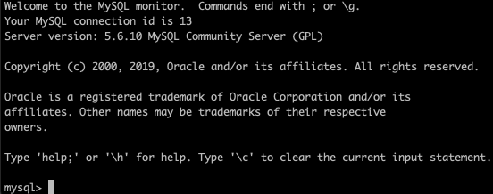

Task 8: Execute Database Operations for Mac/Linux users
- Windows users can follow the details provided in the Tutorial: Execute SQL statements using MySQL workbench and new the output
- Linux/Mac Users can use the terminal to execute SQL commands.
- Enter the command to see the existing databases.
show databases;
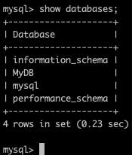
- To delete the MyDB database
DROP DATABASE MyDB;
- Create a Database
CREATE DATABASE SchoolDB;
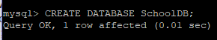
- View the database created
show databases;
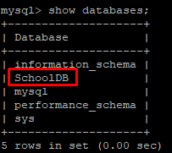
- Switch the database SchoolDB.
use SchoolDB;
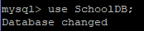
- Create a sample table of students.
CREATE TABLE students (
subject_id INT AUTO_INCREMENT,
subject_name VARCHAR(255) NOT NULL,
teacher VARCHAR(255),
start_date DATE,
lesson TEXT,
PRIMARY KEY (subject_id));
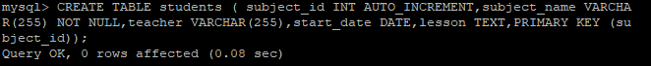
- See the students table.
show tables;
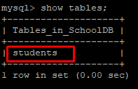
- Insert data into the table
INSERT INTO students(subject_name, teacher) VALUES ('Arts', 'Suzan Carpenter');
INSERT INTO students(subject_name, teacher) VALUES ('English', 'John Taylor');
INSERT INTO students(subject_name, teacher) VALUES ('Science', 'Mary Smith');
INSERT INTO students(subject_name, teacher) VALUES ('Maths', 'Ted Miller');
- Check the items added in the table
select * from students;
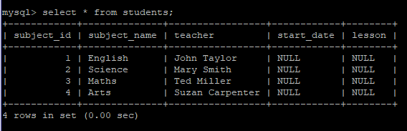

Do you know ?
Amazon Aurora supports read replicas, which are copies of the primary database that can handle read traffic. These replicas can be automatically created and scaled based on demand, allowing for high read scalability and improved performance for read-heavy workloads.

Task 9: Validation Test
- Once the lab steps are completed, please click on the Validation button on the left side panel.
- This will validate the resources in the AWS account and shows you whether you have completed this lab successfully or not.
- Sample output :


Task 10: Delete AWS Resources

10.1 Delete the Aurora Cluster
- Navigate to RDS by clicking on the Services menu available under the Databases section.
- Click on DB Instances.
- Now select the myauroraclsuter-instance-1 and Click on Actions, Select Delete.
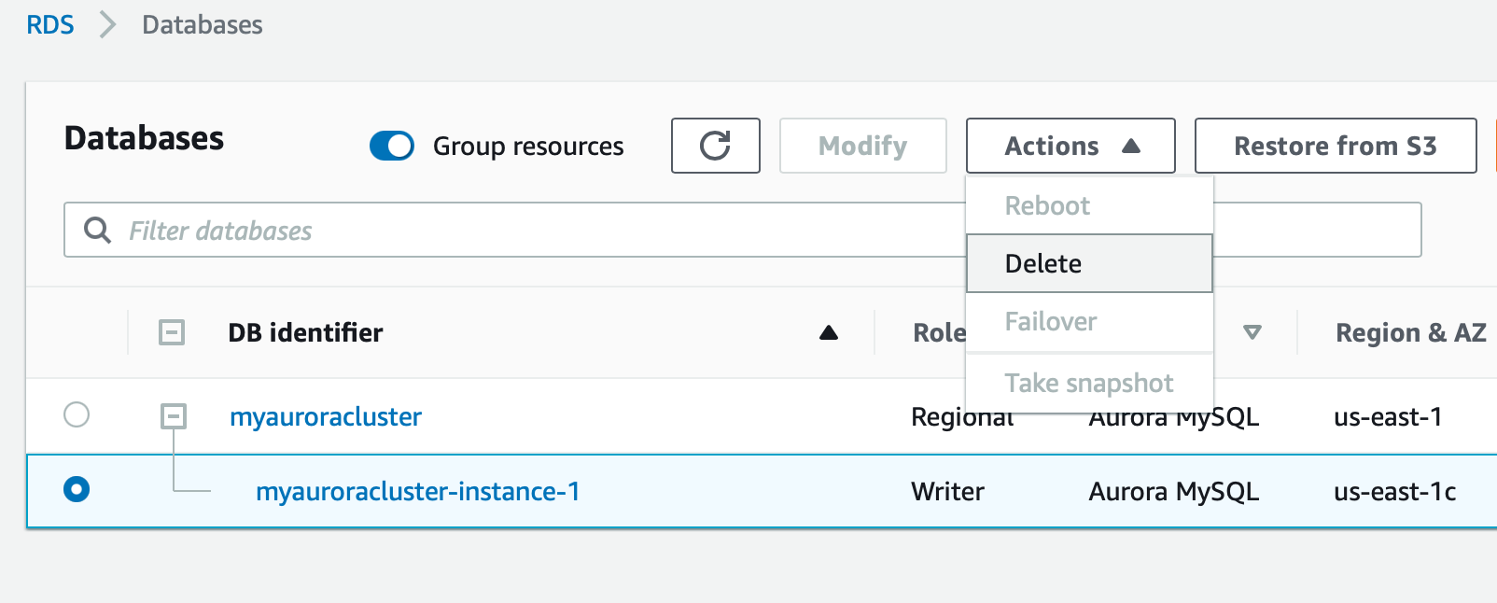
4. To finally delete we have to perform several tasks:
- Uncheck the option of Create final snapshot,
- Acknowledge by selecting the second option,
- Type delete me to confirm
- And finally, click on Delete button below.
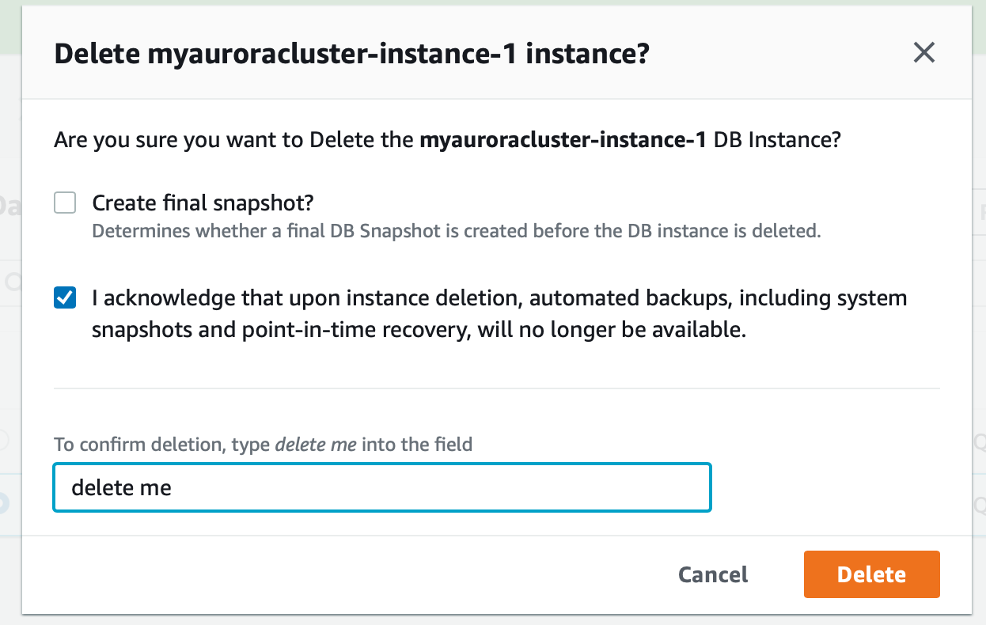
5. Deletion of DB Cluster may take up to 5 minutes, you can end the lab once status becomes Deleting.

10.2 Delete the Security Group
- Navigate to EC2 by clicking on the Services menu available under the Database section.
- On the left panel menu, select the security group under the Network & Security section.
- Select the Aurora_lab_sg, Click on Actions, and select Delete security group
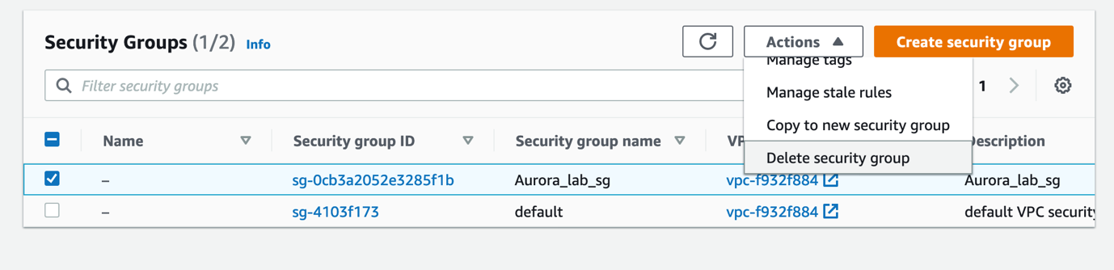
- Note: If you don't find the Delete security group, please scroll downwards.
4. Click on the Delete button.
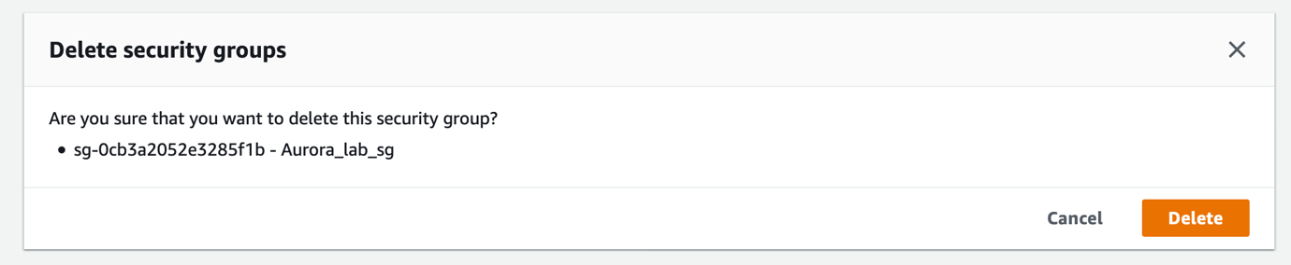
5. The security group is deleted successfully.

Completion and Conclusion
- You have successfully used the AWS management console to create an Amazon Aurora MySQL database.
- You have configured an Amazon Aurora database instance.
- You have successfully connected to the Amazon Aurora database and executed SQL queries against it.

